SENTIMENT ANALYSIS ON RULEMAKING COMMENTS

Sravani Vangala
College of Information
University of North Texas
Denton, TX
SravaniVangala2@my.unt.edu
Mounica Satraboina
College of Information
University of North Texas
Denton, TX
MounicaSatraboina@my.unt.edu
Sai Sharath Ponugubati
College of Information
University of North Texas
Denton, TX
SaiSharathPonugubati@my.unt.edu
Shreshta Poojala
College of Information
University of North Texas
Denton, TX
ShreshtaPoojala@my.unt.edu
Kazi R. Ahmed Siddiquee
College of Information
University of North Texas
Denton, TX
KaziSiddiquee@my.unt.edu

ABSTRACT
This project is designed to perform sentiment analysis on rulemaking comments. The United States has a Federal Government website that acts as an internet portal and document repository, which allows public to be participate in rulemaking process of some Federal Agencies. Through this site the public can share their opinions and thoughts regarding different proposed rulemaking notices in the form of comments. These comments can be accessed publicly in the website. The federal agencies then go through all the comments posted by the public, considering the majority of the opinions before presenting the final rule. But to go through each and every comment word by word and analyzing the user’s sentiment towards the rule requires a lot of human effort and very time consuming. To ease this process, we are proposing a sentiment analysis technique through which machine learning models can predict the sentiment of each comment by identifying the aspects and their sentiment with respect to the comment.
Github link for the project: https://github.com/Sharath-11507563/Aspect-based-sentimental-analysis-on-Rulemaking-comments
.

INTRODUCTION
Sentiment analysis is a process of analyzing people’s opinion, attitude towards particular product, sentiments and emotions that are in the form of written language. It is applicable in web mining, data mining, text mining and is considered as one of the main concepts in Natural Language Processing. Main objective of sentiment analysis is to identify the sentiment of any comment. Sentiment polarity is determined based on the type or orientation of a comment which may be either positive, negative, and neutral. There are four types of sentiment analysis which are Fine-Grained, Aspect based, Emotion Detection and Intent Analysis. In Fine grained analysis, each part of a sentence is broken down into phrases or clauses, and each word is assessed in relation to the others. Emotion Analysis seeks to discover and distinguish emotions such as anger, disgust, fear, pleasure, sadness, and surprise through the expression of words. Intent analysis is the process of determining if email addresses, web links and phone numbers incorporated in email messages are affiliated with legitimate entities. This project is based on Aspect based sentiment analysis where the aspect of each comment is identified and its polarity is determined as positive, negative, or neutral. Aspect based sentiment analysis is a process of categorizing a comment with an aspect and then determine the sentiment of each aspect. An aspect is the distinct feature of a comment. There are two types of aspects that include Implicit aspects and explicit aspects. Implicit aspects are not obvious words in a comment but are human aware sentiments that conveys the inner meaning of the entire comment. Explicit aspects are obvious words in the comment that conveys the meaning of each comment. The criteria that have been followed for identifying aspects in our project is not to consider common words such as Tobacco, Cigarettes and Nicotine as aspects. Determiners, nouns, and pronouns are not considered as aspect terms. Nominal phrases explicitly mentioning aspects and all the occurrences of an aspect term in a sentence must be annotated.
When the federal government adds or alters rules regarding certain topic in the Code of Federal Regulations, it is referred to as rulemaking. These regulations have an impact on everything from the air we breathe to the food we eat as well as our financial stability and health care. Formal rulemaking, Informal rulemaking and Hybrid rulemaking are the three major types of rulemaking. While creating or modifying new regulations on a certain topic, government agencies at state and federal level use informal rulemaking procedure in order to make general public aware of proposed rule and to write their views, comments, or arguments regarding that rule. People are required to comment through a web portal by the federal government at regulations.gov. Public comments that are submitted during the notice and comment time have the potential to alter any course of regulation. As the public in recent years became more engaged in this process, the number of comments have increased into millions. The Administrative Procedure Act required the agencies to identify the comments and respond to them. Agencies struggled to keep up with the volume of submitted comments and made it difficult for them to review and analyze all the received comments manually. Hence there is a need for computational tools that are used for reviewing and analyzing these comments.
In order to identify the sentiment of each comment data annotation technique is used where labels are added to each comment that allows the machine learning models to understand human opinions. The types of annotation that are used are positive, negative, and neutral.
The study of algorithms that improves its learning through experience and with the use of data is known as Machine learning. Machine learning algorithms create a model based on training data to make predictions or conclusions without having to be explicitly programmed to do so. A training set is used to construct a model, whereas a testing set is used to ensure that the built model is correct. A model is developed to predict the test data in Machine Learning. As a result, we fit the model with training data and test it with testing data. Machine learning approaches are Supervised learning and Unsupervised learning. Supervised learning is a type of machine learning that makes use of labeled datasets. These datasets are used to supervise or train the algorithms so that they can accurately identify data or estimate outcomes. The model may test its accuracy and learn over time by using labeled inputs and outputs. Unsupervised learning analyzes and clusters unlabeled data sets using machine learning methods. Without the need for human interaction, these algorithms identify hidden patterns in data. The algorithm learns from the training dataset by iteratively making predictions on the data and adjusting for the correct answer in supervised learning. supervised learning models are more accurate than unsupervised learning models and they require human involvement in the data labeling process. Supervised Machine learning models such as Naive bayes classification, SVM, Decision trees, Random Forest and logistic regression are used in our project and accuracy, precision, recall and f1 scores are calculated for each model.
Research questions:
1. Measure the accuracy of single annotation vs Triple annotation
2. Comparison of performance between different machine learning models
3. Evaluation of results

LITERATURE REVIEW
Alqaryouti et al. (2020) helped bring out the ways in which aspect-based sentiment analysis can be utilized to help government agencies to get insights on expectations and needs of their clients. They constructively explain the ways in which integrated lexicon along with rule-based model are used to handle issues associated with aspect-based sentiment analysis. High performance outcomes were reported. It brought out the ways in which different challenges like intensification, negation, and repeated characters associated with sentiment analysis can be handled. Besides, the comparative rules help to determine the strengths and weaknesses associated with mobile applications of the government (Alqaryouti et al., 2020). The review is critical in inspiring the administration to enhance service delivery to its people. Mobile applications developed by government can enable collection of views, issues, and suggestions from the customers. It is an affirmative way to improve interaction between the government entities and the general population.
Convolutional Neural Network (CNN) approach was shown to have means to detect particular features for both sentiment and aspects categories whether in word or phrase forms irrespective of their position. Bangsa, Priyanta, and Suyanto (2020) managed to classify aspect-based sentiments through CNN and application of Word2Vec feature extraction. The CNN models were noted to depend on the amount of data being used, as the accuracy and datasets are directly proportional. Nonetheless, the researchers believe that there are limitations that can still be addressed. There is need to include a method for evaluating the manifestation target opinion that determine the expression of the phrases and opinion of words linked with aspect entity (Bangsa, Priyanta, & Suyanto, 2020). It is crucial to also add a technique of negation handling in the grouping stage of sentiment. Researchers helped to highlight the ways in which the precision of analysis can be enhanced by evaluating the words and phrases.
Brun and Nikoulina (2018) reviewed state-of-the-art systems as applied on commonly used dataset. They manually created annotated dataset for user produced data from a domain similar to the training dataset. However, they obtained them from other sources and analyzed the differences between the created data and the standard dataset. Researchers conducted the analysis to establish the robustness of the state-of-the-art systems. While examining the baseline data on the new dataset, it was showed that standard aspect-based sentiment analysis could experience a decline in performance, more so for aspect detection (Brun & Nikoulina, 2018). The review involved use of lexicons and integration of in-domain embedding on various systems. Application of the sentiment analysis by the researchers helped to bring out the various ways in which the dataset can be employed in deducing the divergence by examining their relationship with the standard dataset.
Chakraborty, Goyal, and Mukherjee (2020) carried out study through systematic evaluations using aspect-based sentiment. The research involved reviewing scientific papers to help draw useful information. They examined research works and applied active learning framework to create training datasets for aspect prediction. It is further employed to get sentiments and aspects from the whole dataset (Chakraborty, Goyal, & Mukherjee, 2020). Their efforts helped to look at the extent of acceptance or rejection of papers among the reviewers based on the information provided in the papers. Scrutiny of scientific papers showed that aspect sentiments and reviewer scores were concurrent, as the researchers held similar opinions during the reviews. Scientific reviews allow individuals to deduce the writers’ sentiment on the available research works. Most of the content in scientific reviews are linked and the analysis would be effective, as there are minimal variations in the scientific principles.
Do et al. (2019) noted that increased use of internet has led to more user-generated content that is available on websites. It has made sentiment analysis to be a crucial tool for extracting information regarding the emotional state of humans. The researchers adopted deep learning techniques to explore aspect-based sentiment analysis. Their objective was carry out aspect extraction in addition to sentiment categorization in product reviews. Do et al. (2019) indicated that their ability to utilize both semantic and syntactic characteristics of text was crucial in attaining their goals without relying on high-level engineering feature. They helped to highlight the various approaches that individuals can use while carrying out aspect-based sentiment analysis.
Ishaq, Asghar, and Gillani (2020) conducted sentiment analysis by using hybridized methodology centered on Genetic Algorithm (GA) and CNN. They understood that sentiment analysis could be employed on unstructured textual data in assessing the writers’ attitude from the text. Other approaches that are currently being used include lexicon and corpus-based approaches. Nonetheless, the approaches can be time-consuming because of the various blends of features. The researchers’ interest was to analyze sentiments by incorporating various operations including execution of CNN to mine opinion, mining semantic features, and transforming the extracted corpus through Word2vec. It was possible to tune the CNN parameters using GA. The obtained results were better as the accuracy rate was 95.5%, f-measure rate of 96%, precision rate of 94.3%, and recall rate of 91.1% (Ishaq, Asghar, & Gillani, 2020). It indicates that the analysis gave a better outcome compared to state-of-the-art methods.
Liu (2012) posits that sentiment analysis is largely used in the contemporary world especially in the social and business domain, as the opinions are crucial to human activities and influence the behaviors of many people. The author goes ahead to indicate that people’s perceptions and beliefs are commonly dependent on how they view the world. Therefore, people will always depend on how other people’s views or opinions. It applies to organizations as well because the businesses tend to check on how competitors are doing in the field (Liu, 2012). Therefore, the input given by Liu is essential for those interested to research on social media and have interest in sentiment analysis. The publication covers various aspects related to text mining, natural language processing and data mining that are important to aspect-based sentiment analysis.
Thet, Na, and Khoo (2010) do not just focus on the sentiment orientation of either being positive or negative but focus on fine-grained analysis to determine the reviewers’ sentiment strength and orientation toward different movie aspects. They adopted linguistic technique of computing their sentiment from the previous scores assigned to various words. The authors also took into consideration the dependency structure of the clauses on grammar. The approach adopted SentiWordNet in deriving the words with the support of subjectivity lexicon. They handled aspects of negation delicately (Thet, Na, & Khoo, 2010). Their findings was that output scores from sentiment analysis could be employed in identifying the most positive or negative sentences as well as clauses in relation to specific movie aspects. Therefore, their research work could be extrapolated to other fields and aspect analysis of different artworks or films. Their aspect-based sentiment analysis is more of neutral, as they did not pinpoint whether the reviewed movies could be classified as being positive or negative.
Studies indicate that sentiments and opinions from clients can give insights on the product performance in different aspects. Wei (2019) notes that data analysis of customer feedback is increasingly becoming feasible due to availability of data and the influence of natural language processing. It is a positive development that has enabled stakeholders to proactively address the market challenges. Nonetheless, the retailers do not always make good use of the online comments. Therefore, Wei helped in highlighting the different means to summarize and analyze the valuable information. The research aimed at retrieving the data from online resources and created parallel framework to guarantee efficiency as well as extensibility. It creatively helps to demonstrate how the readily available information can be interpreted for improved service delivery.
2.1 Annotation
Most researchers portray positive polarity of aspect-based sentiment analysis in their research works. Statistical analysis uses different approaches including statistical methods where one has to consider the frequency as the feature and entity. The researchers use the number of words in sentiment analysis and use them in hybrid machine learning models. Moreover, the aspect-based sentiment analysis is commonly used in daily activities. In online rating plans, the general rating of entities may not exhaustively elaborate about their qualities. For instance, the restaurant environment may involve getting feedback from customers and analyzing their opinions such as ambience (positive), service (positive), food quality (positive), and price range (negative).
The publications done by various authors cover various aspects related to text mining, natural language processing as well as data mining that are important to aspect-based sentiment analysis. Application of the sentiment analysis by the researchers helps to bring out the various ways in which the training dataset can be employed in deducing the views of different people. The application of ABSA cuts across the general population and has been employed in various fields to help improve the lives of people. Both private and public sectors have found it useful in engaging their customers to offer better services and products.
Sentiment Analysis (SA) touches every aspect (e.g., entity recognition, coreference resolution, negation handling) of Natural Language Processing (Liu, 2012) and as Cambria et al. (2013) mention “it requires a deep understanding of the explicit and implicit, regular and irregular, and syntactic and semantic language rules”.
Aspect Based Sentiment Analysis (ABSA) systems take a series of texts that discuss a specific entity as input. The systems try to identify the entity's most important (e.g., most frequently discussed) properties (features) and estimate the average sentiment of the texts per aspect. Even though various ABSA systems have been presented, most of which are research prototypes (Liu, 2012), there is no standard task decomposition for ABSA and no established assessment methods for the subtasks ABSA systems must fulfill. The Aspect Based Sentiment Analysis contains three steps such as aspect term extraction, aggregation and polarity.
Precision, recall, and F-measure are commonly used to assess ATE methods (Hu and Liu, 2004; Popescu and Etzioni, 2005; Kim and Hovy, 2006; Wei et al., 2010; Moghaddam and Ester, 2010; Bagheri et al., 2013), but it's not always clear whether these metrics are applied to distinct aspect terms (no duplicates) or aspect term occurrences (tokens)
2.2 Model Construction
There are various models in machine learning to enhance the performance.
Joachims (2006), SVM is a multi-variate performance measure version of SVM that uses an alternate structural formulation of the SVM optimization problem for binary classification. Hyper planes are used to examine data and set decision limits. The hyper plane divides the document vectors of one class from those of other classes in the two-category scenario, where the separation is kept as large as possible (Hsu et al. 2003).
Rajasekhara Reddy Chinta (2020) explained Logistic regression is a classification function that employs a single multinomial regression model with a single estimator and uses class as the building block. In a specific technique, logistic regression usually states where the class border exists, as well as how the class probabilities rely on distance from the boundary. When the data set is more significant, this goes even faster towards the limits (0 and 1)—these probabilistic claims that distinguish calculated regression from a classifier. One of the most often used tools for applied statistics and discrete data analysis is logistic regression. Linear interpolation is a technique used in logistic regression.
L Jiang et al., Nave Bayes (NB), created by is a reasonably simple machine learning technique based on probability models and the Bayesian theorem. This classification technique examines the relationship between each feature value and the class for each instance to obtain a conditional probability for those correlations. The NB conceptual framework is based on the estimation of the probabilities of a given document belonging to a certain Class using combined probabilities of features and Classes.
Shomona, Kalai Magal, Gracia Jacob stated that to improve the classification accuracy for software fault prediction, suggested a new Improved Random Forest approach. To achieve improved accuracy, the method combined the best feature selection technique with the Random Forest. The CFS algorithm finds the best collection of features based on correlation. The best attributes were then loaded into a Random Forest classification system to improve software flaw detection accuracy.
Lertworaprachaya et al., 2014 [1] proposed a novel Decision tree algorithm model for composing decision trees with interval valued fuzzy membership values. Most extant fuzzy decision trees do not consider the concerns connected with their membership values; nonetheless, exact membership values are not always available. The authors used fuzzy sets to assess the relevance of various neighborhood values and to construct a new metric that is unfriendly to certain data sets.
2.3 Feature Selection:
Feature selection models for text processing:
Cavnar and Trenkle, 1994 tells n-grams allow for language-independent processing, tracking of lexical and contextual information, more robust behavior in the presence of various types of textual errors because errors only affect a small number of grams and automatic detection of words with the same root form (Stamatatos, 2009). There are various text Processing techniques. Modern natural language processing (NLP) and its applications rely heavily on N-gram-based approaches. Traditional n-grams are element sequences that emerge in literature.
Garreta and Moncecchi (2013) says,it conveys the significance of the term to the document and the corpus as a whole. Term frequency indicates the frequency of a word in a document, while IDF indicates the frequency of a certain term throughout the entire corpus.Term frequency-inverse document frequency is abbreviated as tf-idf. It's a metric that measures how essential a word is in a collection or corpus of documents.
Garreta and Moncecchi(2013) convert the text document collection to a matrix of integers . This method aids in the generation of a sparse count matrix. The TF-IDF value rises as the number of times a word appears in the document. The term frequency is offset by the frequency of words in the corpus to control the generality of more commonly used words. The number of times a phrase appears in the text is referred to as term frequency. The occurrence of a term in all papers is measured by inverse document frequency.
Alla Alahmadi and Arash Joorabchi had two issues with text classification. One was that the text was broken down into its constituent words, and the other was that synonyms were treated as separate features. To address this issue, a set of ideas was devised that attempted to remove synonyms from the text, with the added benefit of capturing and retaining the semantics of words present in the document.
Recognizing and extracting accurate name items, such as Persons, Locations, and Organizations, is critical for mining data from text. Named Entity Recognition is the process of extracting names from natural language literature. Vichot et al., 1999; Wolinski et al., 2000, the performance of a NERC system degrades over time due to the introduction of new NEs or the change in the meaning of existing ones.
Ng, (2008),the process of identifying noun phrases that relate to the same real-world thing is called coreference resolution (Ng, 2008). In this context, such noun phrases are called mentions, or just anaphoric noun phrases. Mentions can be either named, nominal or pronominal (Luo, 2007).

DATA COLLECTION
Our project is based on sentiment analysis on rulemaking comments. For this we are using the official Federal website of United States where the official regulations regarding all rules are updated and are available for public to review and comment their opinions and thoughts. The link for official website is: https://www.regulations.gov/
As there are very wide range of topics in the regulations data, to concentrate on rich data quality, we chose to extract data related to a single topic. That topic is Tobacco Products.
We used the web scraping techniques using NLTK libraries to collect data from the website. To extract data from this website a user will need an API key (Application Processing Information). An official request to the developer team has to be made. After getting the key, using the api url we can access the html code of the website, through which we can search the content we want to scrape.
Then using beautiful soup we have extracted the json data of the website. Through this data we have extracted the attributes and data that we were aiming for. We were able scrape data of about two thousand comments related to different dockets/regulations.
The attributes that we collected for the data are:
- Docket_Id: the unique identification alpha-numerical code for each regulation which can be used to extract details of that particular regulation.
- Comment_Id: the unique identification alpha-numerical code for each comment posted to the respective regulation.
- Comment: the posted individual public comments of that respective docket/regulation.
The docket_Id and Comment_Id is unique all through the website.
We have extracted comments from the following rulemaking regulations:
FDA-2010-D-0277- Compliance with Regulations Restricting the Sale and Distribution of Cigarettes and Smokeless Tobacco to Protect Children and Adolescents, Availability
FDA-2010-N-0136- Implementation of the Family Smoking Prevention and Tobacco Control Act Request for Comments
FDA-2010-N-0568 – Required Warnings for Cigarette Packages & Advertisements
FDA-2011-N-0493 – Regulations Restricting the Sale and Distribution of Cigarettes and Smokeless Tobacco to Protect Children and Adolescents
FDA-2012-N-0977 – Standards for Pipe Tobacco and Roll-Your-Own Tobacco
FDA-2013-N-0227 – Tobacco Product Manufacturing Practice; Establishment of a Public Docket
FDA-2013-N-0521 – Menthol in Cigarettes, Tobacco Products; Request for Comments
FDA-2015-N-2002 – Clarification of When Products Made or Derived From Tobacco Are Regulated as Drugs, Devices, or Combination Products
FDA-2019-N-2854 - Premarket Tobacco Product Applications and Recordkeeping Requirements
The aspects used in this project are explicit aspects as they are stated directly and are easy to identify. Also, the implicit aspects might be difficult for the model to understand. For the aspect identification we have followed a criterion in order to increase the quality of the aspects identified.
- Common words such as Tobacco, cigarettes and Nicotine cannot be used as aspects.
- No Nouns and pronouns can be aspects.
- Determiners such as ‘a’, ‘an’, ‘the’, ‘for’, ‘few’, ‘more’ should not be included as aspect terms.
- Nominal phrases explicitly mentioning aspects should be annotated.
- Example: I support efforts in protecting children and adolescents from the availability of the sale and distribution of cigarettes.
- Here the aspect term should be “sale and distribution” rather than “sale” and “distribution”.
- All the occurrences of an aspect term in a sentence must be annotated.
In order to increase the accuracy of annotation of the data, we have decided to annotate the data three times, so that we could get different perspectives of the data. Three of our team members have annotated the data with respect to the sentiment of the aspect in the whole comment. Hence the sentiment was identified as positive, negative and neutral.

EXPLORATORY DATA ANALYSIS
After performing some data analysis on the data to find the diversity and content of each comment, we have found the number of sentences, number of words, number of characters, and average word length for each comment and also for the whole data that we have collected.
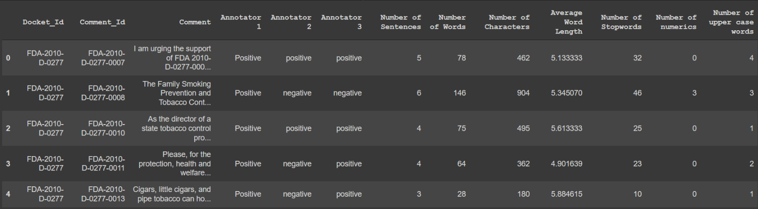
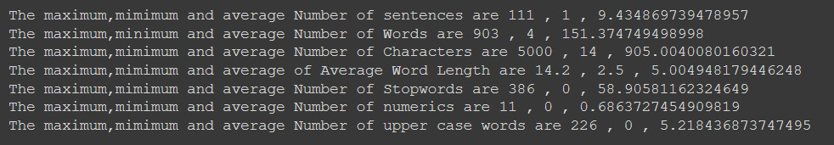

DATA PRE-PROCESSING
To eliminate unnecessary data from the comment data, we have eliminated data that is irrelevant and unnecessary for the models. There were records where the comments were uploaded as documents and no useful information could be scrapped. All such records were eliminated. Also, to increase data quality we have performed several pre-processing techniques using the NLTK libraries to eliminate stop words and lemmatize and stem the data.
Eliminating these words can help increase data quality and has direct impact on the model accuracy. In this process regular expressions and emoticons and all other symbols are removed.

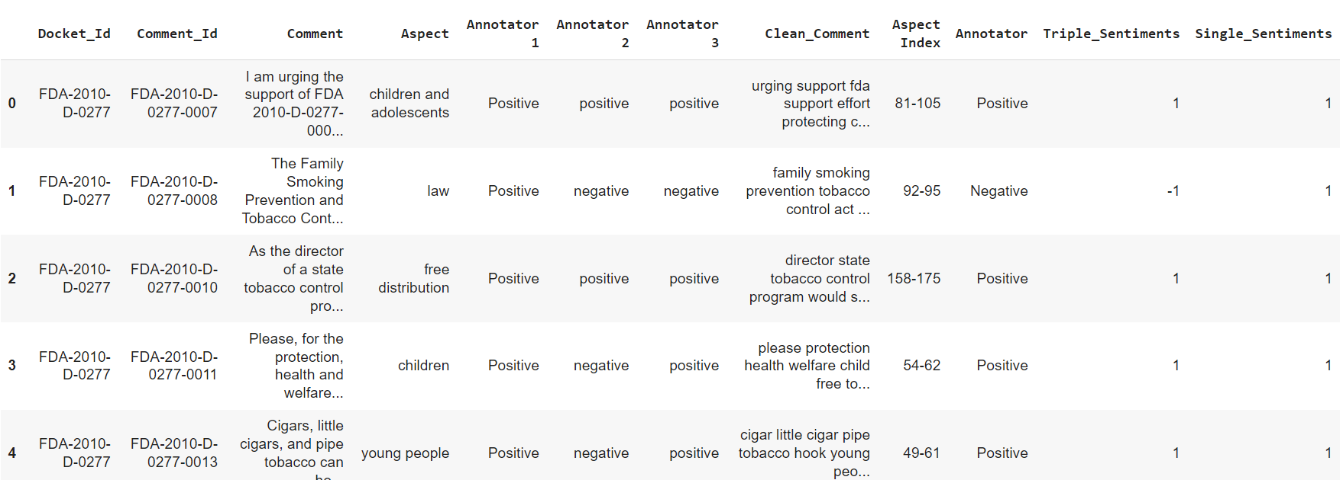

METHODOLOGY
In this project, we would be using traditional machine learning models such as Naïve-Bayes classifier, SVM, Decision Tree, Random Forest and Logistic Regression models. These were chosen as our target variable has a finite number of outcomes (to be precise, 3). All models are trained under supervised machine learning techniques.
Naïve-bayes model is based on the concept of ‘conditional probability’ used in Bayes Theorem. This naivety of this model is due to the assumption that the variables are independent to each other i.e., change in a variable does not affect the other variables. But this model is very quick in processing the data and giving the output.
Naïve-bayes formula:
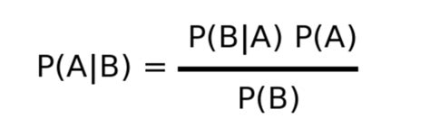
SVM (short for Support Vector Machines) performs classification by identifying hyperplanes with maximum margin distance between the classes of data. Hyperplanes are the decision boundaries which help is classifying our data. The datapoints divided by this hyperplane can be attributed as different classes. The dimension of this hyperplane is decided by the number of features being classified. If there are 2 features to be classified, the hyperplane is a line and if the number of features is 3 then, the hyperplane is a two-dimensional plane.
SVM vectors:
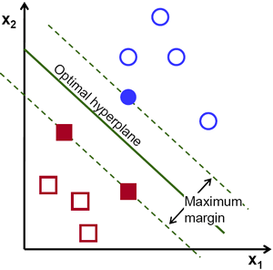
A decision tree is a set of nested tests which we use to solve a prediction problem. It is made up of branches, nodes and leaves. Each branch represents a test. Each node represents the result of a test. Each leaf (terminal node) represents a class assignment. The factor that makes it so useful for representing data, is the way in which branching maps to our notion of categorical outcomes. A decision tree takes advantage of this characteristic and allows us to view our data as filtering down through several decisions (splits in the tree) until finally coming to rest at a leaf. We can then examine the properties of each leaf and determine how they relate to our dependent variable. Using inductive reasoning, we can then generalize about the nature of observations that appear in each leaf. This allows us to pass new data through our tree and speculate about outcomes based on the leaf in which a given observation comes to occupy. Decision trees have an advantage that it is easy to understand, lesser data cleaning is required, non-linearity does not affect the model’s performance and the number of hyper-parameters to be tuned is almost null. However, it may have an over-fitting problem. This problem can be limited by implementing the Random Forest classification in place of the Decision Tree classification. Additionally, the Random Forest algorithm is also very fast and robust than other regression models. The Decision Tree is an easily understood and interpreted algorithm and hence a single tree may not be enough for the model to learn the features from it.
Decision Tree:
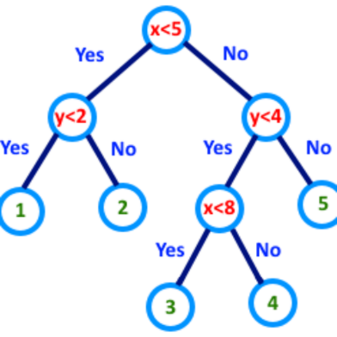
On the other hand, Random Forest is also a “Tree”-based algorithm that uses the qualities features of multiple Decision Trees for making decisions. Therefore, it can be referred to as a ‘Forest’ of trees and hence the name “Random Forest”. The term ‘Random’ is because this algorithm is a forest of ‘Randomly created Decision Trees’. To summarize in short, The Random Forest Algorithm merges the output of multiple Decision Trees to generate the final output.
Random Forest:
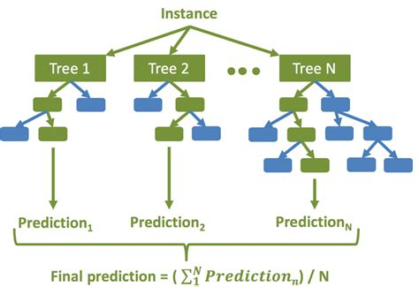
Logistic regression is a popular Machine Learning algorithm that is part of the Supervised Learning techniques. It is used to predict the categorical dependent variable from a set of independent variables. This algorithm forecasts a categorical dependent variable's output. As a result, the result must be a categorical or discrete value. It can be Yes or No, 0 or 1, true or False, and so on, but instead of giving the exact values as 0 and 1, it gives the probabilistic values that fall between 0 and 1. Except for how they are used, it is very similar to Linear Regression. Logistic regression is used to solve classification problems, whereas linear regression is used to solve regression problems. The value of the logistic regression must be between 0 and 1, which cannot go beyond this limit, so it forms a curve like the "S" form. The S-form curve is called the Sigmoid function or the logistic function.
Logistic regression:
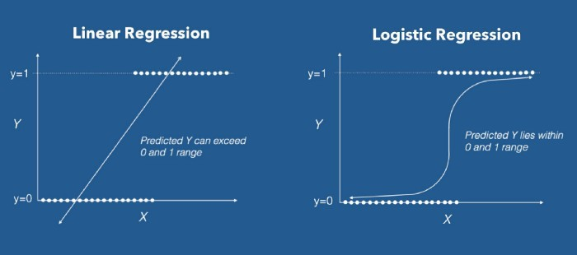

Methodology Flowchart:
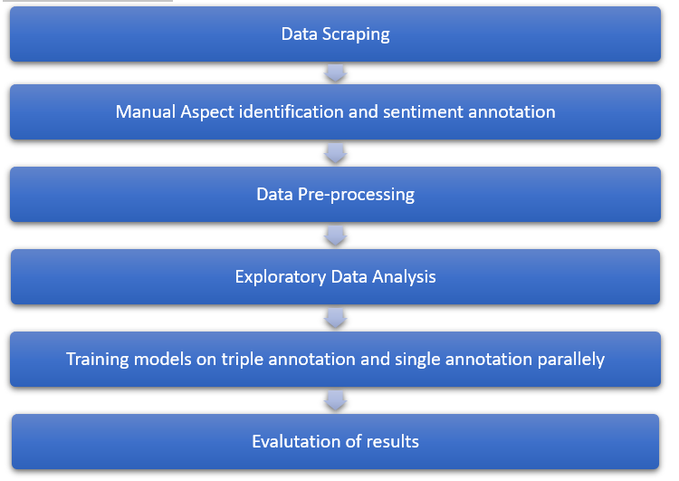

DATA ANALYSIS
Over the course of this project, we conducted various experiments and learnt a lot of lessons on why some methods won’t work for a particular situation. This involved a lot of hit or miss experiments we performed, and we were surprised by the results. Our experiment of comparing results between triple annotated dataset and single annotated dataset led us to acquire good amount of domain knowledge on various issues and factors related to tobacco products. This began by team members spending a good amount of time to research about various topics including but not limited to, use of menthol in cigarettes, comparing the harm done by cigarettes compared to vapes, effect of tobacco advertisements on various age groups etc. As there were three different annotators working on the same data, we had to come up with a list of annotation criteria to have a guideline on how to identify the aspect and annotate the sentiment. Initially, we saw a not-so-good similarity between the results of the annotation. This called for a streamlining session between the annotators in which we discussed the scenarios where we saw a difference in the outcomes and had a more organized understanding of annotation. After this meeting, we annotated the dataset again and saw a good increase in the similarity between annotators work. After tackling with the problem of having a homogenous annotation, we again checked the Kappa-score which gives us the inter-relatability between the outcomes presented by the different annotators. As all the kappa values fell between the range of 0.7-0.86, which tells us that there is substantial agreement between all the annotators, we went ahead with the rest of our experiments. As the rules we collected were for changes on tobacco products, we saw a lot of people expressing their anger towards these changes and as a result, our data was heavily skewed towards negative sentiment. To counter this partiality in the data, we had to use a stratified k-fold cross validation to measure the accuracy of the models we ran. As the input was in the form a string and the target variable was a numeric outcome, we had to vectorize the string input. We initially started by using TF-IDF vectorizer and quickly realized that this decision did not give us the best of the results. During a meeting with our mentor (Ms. Huyen Nguyen), she suggested we use count vectorizer instead of TF-IDF. This resulted in a better performance of our models. We ran a total of 5 traditional classification models- Naïve-bayes, SVM, Decision Tree, Random Forest and Logistic regression with two iterations for each model. The first iteration had the input of the best of 3 annotator results as input and the second had only one annotator’s result as input.

RESULTS
We used multiple metrics to compare the performance of the various models that were used in this project. Cohen’s Kappa score, confusion matrix, precision, recall value, F1-score and accuracy were all used.
- Cohen’s Kappa score: Cohen’s kappa is a metric often used to assess the agreement between two annotators. It can also be used to assess the performance of a classification model.
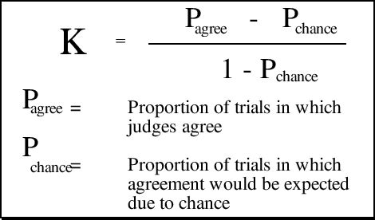
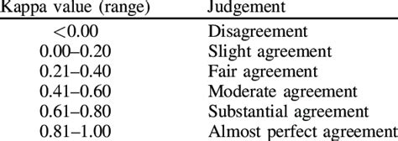

- Confusion Matrix: Confusion Matrix is a performance measurement for the machine learning classification problems where the output can be two or more classes. It is a table with combinations of predicted and actual values.
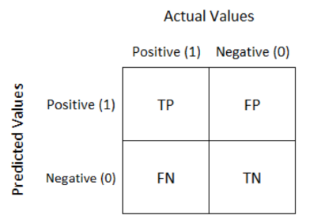
- Precision: Precision explains how many of the correctly predicted cases actually turned out to be positive. Precision is useful in the cases where False Positive is a higher concern than False Negatives.

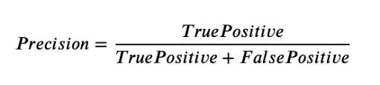

- Recall: It explains how many of the actual positive cases we were able to predict correctly with our model. It is a useful metric in cases where False Negative is of higher concern than False Positive.
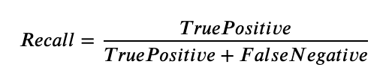
- F1-score: It gives a combined idea about Precision and Recall metrics. It is maximum when Precision is equal to Recall. F1 Score is the harmonic mean of precision and recall.

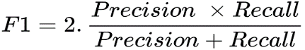

- Accuracy: Accuracy simply measures how often the classifier correctly predicts. We can define accuracy as the ratio of the number of correct predictions and the total number of predictions.
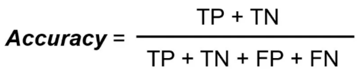

Now that all the metrics have been introduced onto the paper, below tables show the results achieved by the models that were trained for this project

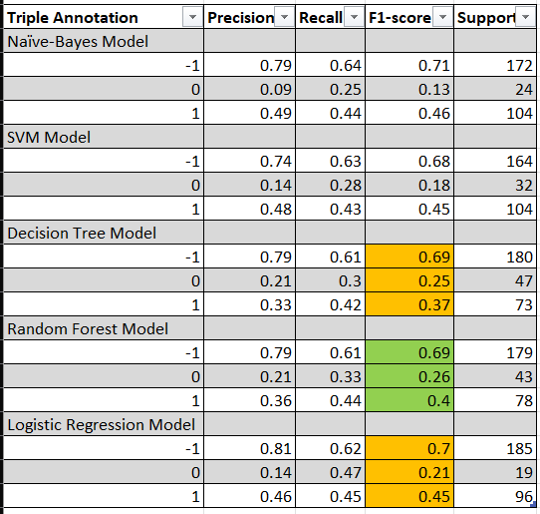
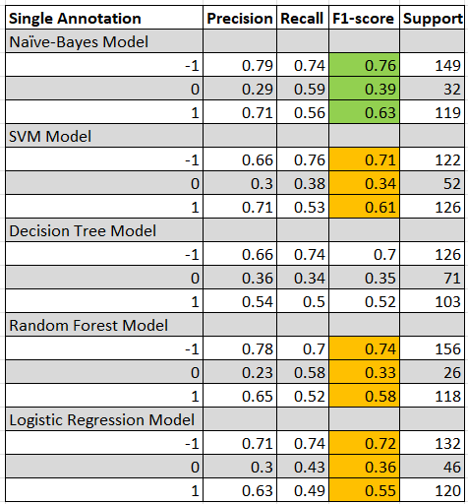
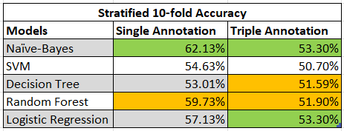

CONCLUSIONS
As result of this project, we can see that annotation is the key part for aspect-based sentiment analysis. The prediction of the sentiment can be high when multiple annotators work on the sentiment identification and the best from all the annotation can be considered as the majority vote. The F1-score is very reliable metric to analyse the model’s performance. As we can see from the results table, it is evident that the random forest model outperformed the other models in the triple annotation.

ACKNOWLEDGMENTS
This project would not been possible with the help and guidance of our project mentor Huyen Nguyen, PhD candidate at University of North Texas, Denton, and our Instructor Haihua Chen, professor at University of North Texas. Our mentor has helped us by guiding the processes in the project and helped us learn new concepts through this research. And thanks to our instructor for the course through which we learned many natural language processing techniques which we have included in our project, such as, web scraping, pre-processing, feature extraction and feature selection. We have used all the techniques that this course has helped us learn, throughout the project.

REFERENCES
- Zecevic, A. (2011). N-gram Based Text Classification According To Authorship. RANLP.
- Tripathy, A., Agrawal, A., & Rath, S. K. (2016). Classification of sentiment reviews using n-gram machine learning approach. Expert Systems with Applications, 57, 117-126.
[3] Gaydhani, A., Doma, V., Kendre, S., & Bhagwat, L. (2018). Detecting Hate Speech and Offensive Language on Twitter using Machine Learning: An N-gram and TFIDF based Approach. ArXiv, abs/1809.08651.
[4] Kawamae, N. (2016). N-gram over Context. Proceedings of the 25th International Conference on World Wide Web.
[5] SoumyaGeorge, K., & Joseph, S. (2014). Text Classification by Augmenting Bag of Words (BOW) Representation with Co-occurrence Feature. IOSR Journal of Computer Engineering, 16, 34-38.
[6] Mansouri, A., Affendey, L.S., & Mamat, A. (2008). Named entity recognition approaches.
[7] Clark, J., & González-Brenes, J.P. (2008). Coreference Resolution: Current Trends and Future Directions.
[8] F.Y, O., AkinsolaJ.E., T., Awodele, O., HinmikaiyeJ., O., Olakanmi, O., & Akinjobi, J. (2017). Supervised Machine Learning Algorithms: Classification and Comparison. International Journal of Computer Trends and Technology, 48, 128-138.
[9] Pranckevičius, T., & Marcinkevicius, V. (2017). Comparison of Naive Bayes, Random Forest, Decision Tree, Support Vector Machines, and Logistic Regression Classifiers for Text Reviews Classification. Balt. J. Mod. Comput., 5.
[10] Pranckevičius, T., & Marcinkevicius, V. (2017). Comparison of Naive Bayes, Random Forest, Decision Tree, Support Vector Machines, and Logistic Regression Classifiers for Text Reviews Classification. Balt. J. Mod. Comput., 5.
[11] Chinta, R. (2020). Review on Various Supervised Machine Learning Algorithms used in Data Science. EngRN: Automation & Robotics (Topic).
[12] Lertworaprachaya, Y., Yang, Y., & John, R.I. (2014). Interval-valued fuzzy decision trees with optimal neighbourhood perimeter. Appl. Soft Comput., 24, 851-866.
[13] Alqaryouti, O., Siyam, N., Monem, A. A., & Shaalan, K. (2020). Aspect-based sentiment analysis using smart government review data. Applied Computing and Informatics.
[14] Bangsa, M. T. A., Priyanta, S., & Suyanto, Y. (2020). Aspect-based sentiment analysis of online marketplace reviews using Convolutional Neural Network. IJCCS (Indonesian Journal of Computing and Cybernetics Systems), 14(2), 123-134.
[15] Brun, C., & Nikoulina, V. (2018, October). Aspect based sentiment analysis into the wild. In Proceedings of the 9th Workshop on Computational Approaches to Subjectivity, Sentiment and Social Media Analysis (pp. 116-122).
[16] Chakraborty, S., Goyal, P., & Mukherjee, A. (2020, August). Aspect-based sentiment analysis of scientific reviews. In Proceedings of the ACM/IEEE Joint Conference on Digital Libraries in 2020 (pp. 207-216).
[17] Do, H. H., Prasad, P. W. C., Maag, A., & Alsadoon, A. (2019). Deep learning for aspect-based sentiment analysis: A comparative review. Expert Systems with Applications, 118, 272-299.
[18] Ishaq, A., Asghar, S., & Gillani, S. A. (2020). Aspect-based sentiment analysis using a hybridized approach based on CNN and GA. IEEE Access, 8, 135499-135512.
[19] Liu, B. (2012). Sentiment analysis and opinion mining. Synthesis lectures on human language technologies, 5(1), 1-167.
[20] Madhoushi, Z., Hamdan, A. R., & Zainudin, S. (2019). Aspect-based sentiment analysis methods in recent years. Asia-Pacific Journal of Information Technology and Multimedia, 7(2), 79-96.
[21] Thet, T. T., Na, J. C., & Khoo, C. S. (2010). Aspect-based sentiment analysis of movie reviews on discussion boards. Journal of information science, 36(6), 823-848.
Wei, J. (2019). Parallel analysis of aspect-based sentiment summarization from online big-data. Master of Science (Computer Science).

